RISC-V Compiler Installation Guide

## Preface

This document outlines how to install the RISC-V compilers for both Linux and Windows. The Windows guide is based on the tutorial at (<https://www.emdalo.com/posts/risc-v-gnu-compiler-toolchain-howto-compile-on-windows/>) and the Linux guide is based on the tutorial at (<https://riscv.org/software-tools/risc-v-gnu-compiler-toolchain/>). Feel free to use these as a reference when following this guide. **Be warned that the download for the compilers usually take 1.5hrs, and the make installation can take up to 1hr (Sorry not sorry).**

## Windows Guide

The RISC-V compilers were built to be used on Linux machines. This means we must trick the compilers into thinking they are on a Linux machine by using MSYS2 (<http://www.msys2.org/>).

**NB** – Most users will want the x86-64 version.

1. Once MSYS2 has been installed we must install the required tools and dependencies for the RISC-V compilers. Open a MSYS2 MSYS console:

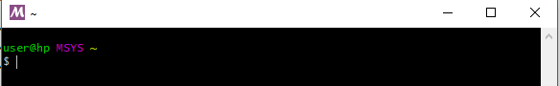

* 1. Install the “mingw-w64-i686-toolchain” i.e type “pacman -S mingw-w64-i686-toolchain”  
       
     **NB –** Choose all/default by pressing enter
  2. Install “make, autoconf, texinfo, diffutils, bison” i.e type “pacman -S autoconf bison diffutils make tar texinfo”

Close this MSYS2 MSYS console.

1. Next, we must install the RISC-V compilers themselves. Open a MSYS2 mingw32 console:

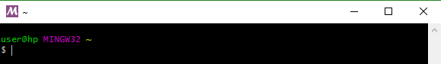

* 1. Download the latest source tree:   
     $ git clone --recursive <https://github.com/riscv/riscv-gnu-toolchain>  
     **NB –** This can take upwards of an hour to complete.
  2. Verify that the system has chosen the right GCC compiler  
     $ which gcc   
     This should then display:

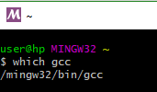

* 1. Verify that you have the right version  
     $ gcc -v  
     At the time of writing (2019) this was returned:  
     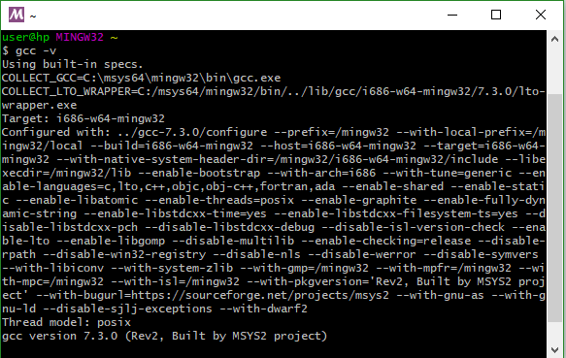

Where “gcc version 7.3.0 (Rev2, Built by MSYS2 project)” is the version

* 1. Change into the RISC-V GNU toolchain directory

$ cd riscv-gnu-toolchain

From here we’re going to configure the compiler for the CPU we have, which is RV32I (Base Integer ISA). First, we must add the compilers to the path. Navigate to “C:\msys64\home\<username>”. In this folder you will find the “.bashrc” file. Open this with your favorite text editor and enter the lines as follows.



* 1. Then return to the MSYS command line and type:

$ ./configure --prefix=/opt/riscv --with-arch=rv32i –disable-linux

* 1. Then run the make for the compilers

**NB –** On a fast machine this can take 45 mins, however on slower machines it can take upwards of an hour  
$ make -j4 > make.log 2> make.err

* 1. As a final sanity check run:  
     $ file /opt/riscv/bin/riscv-unknown-elf-gcc.exe  
     This should report: “PE32 executable (console) Intel 80386, for MS Windows

## Linux Tutorial

1. Download the latest source tree:   
   $ git clone --recursive <https://github.com/riscv/riscv-gnu-toolchain>  
   **NB –** This can take upwards of an hour to complete.
2. Next install the pre-requisite software:  
   $ sudo apt-get install autoconf automake autotools-dev curl libmpc-dev libmpfr-dev libgmp-dev gawk build-essential bison flex texinfo gperf libtool patchutils bc zlib1g-dev libexpat-dev
3. Like the windows guide 2.d, add /opt/riscv/bin to your path
4. Like the windows guide 2.e and configure the compilers
5. Then simply run make